Autonomous Steering Mechanism

Main Report

Contents

Introduction 2

Project Documentation 3

Timeline 3

Problem Statement 4

Ideation & Morphological Table 4

1. Motor type 4

2. Coupling Position 4

3. Motor to Steering Coupling 4

4. Disengagement 4

Scoring Matrix 5

1. Performance 5

2. Precision & Accuracy 5

3. Reliability & Durability 5

4. Complexity & Integration 5

5. Cost-Effectiveness 6

6. Maintainability 6

7. Safety 6

8. Modularity 6

9. Scalability & Flexibility 6

Issues & Feedback 7

Design 8

Pulley/Belt Design 8

Determine Shaft diameters 8

Belt Selection 10

General Selection Procedure – Synchronous belt pulley system 12

1) Pulley selection 12

2) Determine the service factor. 13

3) Calculate the design power. 14

Determine required pitch of the belt. 15

Determine the velocity ratio VR belt between the driver and driven sprockets. 16

Pulley selection 17

Analysis of Motor and Column Shaft 20

Obtain dimensions from Solidworks ’22 Full Car Model 20

Double U-joint Analysis 21

Calculation – Motor Shaft Torsion – Solution 1 22

Calculation – Hollow Steering Shaft Torsion – Solution 1 24

Calculation – Motor Shaft Torsion – Solution 2 27

Radial Force Calculation – Solution 2 30

Combined Radial, bending and Torsion Calculation – Solution 2 30

Axial Forces 35

Finite Element Analysis Simulation 35

Steering Column Shaft – Torsion forces modeled only 35

Steering Column Shaft – All Calculated forces modeled 40

# Introduction

This project involves designing a mechatronic system which enables the steering mechanism on the 2022-2023 UTS Motorsports FSAE car to be controlled autonomously. The steering system consists of a steering wheel, universal joint linkages and a steering column into a worm drive steering rack.

The engineer must consider ergonomic constraints as the vehicle must be both manually and autonomously operated. Further, competition regulations must be kept in mind throughout the design process so the final solution can form part of a fully rules-compliant competition car.

Successful completion of this project allows this year’s team to migrate to the newer 2022/23 chassis and progress towards our goal of having a rules compliant autonomous Formula SAE car. The stakeholders involved include UTS Motorsports, UTS and team sponsors.

The proposed design composes of a BLDC mounted on a bracket onto the floor of the car, which is accompanied by a wedge which would help orient the motor to be parallel to the steering column. The motor is then connected via a series of gears and pulleys.

# Project Documentation

The project scope includes the following design documentation:

* Timeline
* Ideation
* Morphological Table
* Scoring Matrix

## Timeline

Below is a flow chart of the process we followed to achieve the final design.

Figure 1: Timeline Flowchart

## Problem Statement

Design an electromechanical control system capable of rotating the steering column of the UTSMA autonomous car, ensuring it fits safely and ergonomically within the footwell while complying with the FSAE competition regulations.

## Ideation & Morphological Table

Ideating followed the basic principles of discussing how the product could be broken down into sub-assemblies which can be solved individually. These segments include:

### Motor type

This was mainly condensed to two options: A BLDC or a Stepper. Finally, a BLDC Motor was selected: AK80-9.

### Coupling Position

Positioned at the bottom of the steering column to make full use of space constraints with Cockpit Template (Refer to FSAE rules).

### Motor to Steering Coupling

Belt and Pulley drive

### Disengagement

Since the selected motor is backdrivable, the system can be electrically disengaged. Therefore, the considered idea of a mechanical disengage was discarded.

Figure 2: Morphological Table

## Scoring Matrix

Suitable and relevant components were selected from each of the morphological table categories and made into defined “designs”. This would be rated by the following criteria:

### Performance

Delivering the calculated amount of torque without any compromise to the motor.

### Precision & Accuracy

The ability of the steering system to precisely follow the desired path and make accurate adjustments.

### Reliability & Durability

The system’s ability to consistently perform under various operating conditions and resist wear and tear.

### Complexity & Integration

How easy the system is to design, implement, and integrate with the rest of the vehicle, including sensors, controllers, and other hardware.

### Cost-Effectiveness

The overall cost of the steering system, including the cost of components, manufacturing, and maintenance.

### Maintainability

The ease with which the system can be repaired, upgraded, or serviced.

### Safety

Built-in safety features, fail-safes, and redundancy to prevent system failures from compromising the vehicle’s performance.

### Modularity

Ease of create a modular variant, that is compliant with FSAE rules.

### Scalability & Flexibility

Ease of using current design to be used in future iterations.

Using these criteria, the following design was proposed:

BLDC controlled using a magnetic rotary encoder (being positioned directly at the end of the motor shaft). It would be situated in the floor, driven by a set of gears and pulleys. The system can be disengaged by electrically disconnecting the motor, as it is backdrivable. This is shown in the figure below. However, with a slight change in motors led to the sensor being discarded.

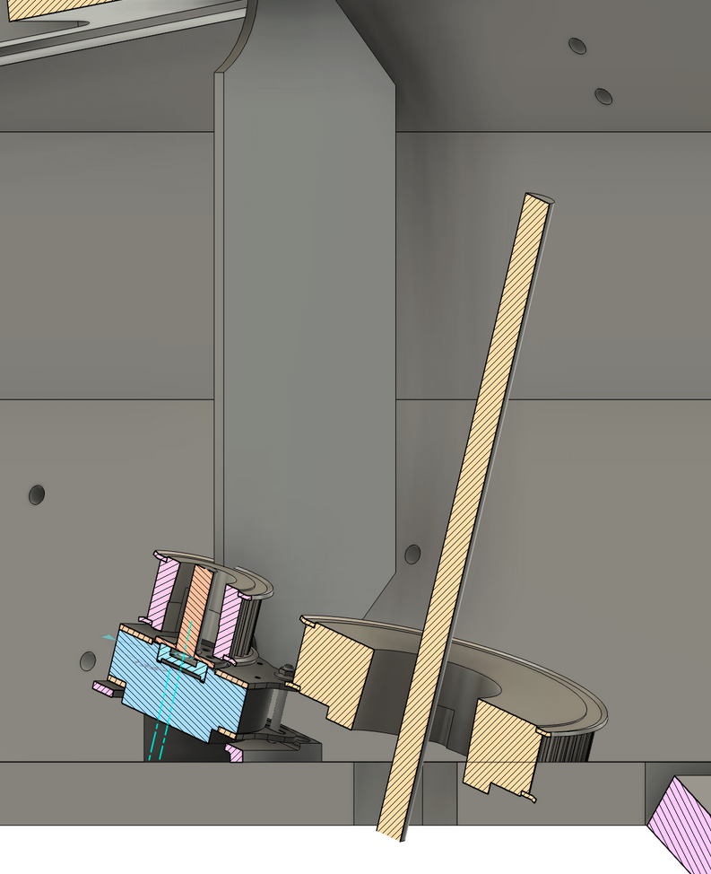

Figure 3: Mechanism fitted in Car Cockpit

# Issues & Feedback

* Motor torque calculations took a long time to confirm and validate, resulting in the team being able to purchase component (which has to be verified with tutor using calculations and confirmation from UTSMS) a couple of weeks in.
* Communications were not consistent in the first few weeks, which unfortunately was not completely resolved even by the end of the project.
* Issues with team members not showing up to meetings and not living up to agreements on time.
* Issues with final design not being in accordance with space constraints (refer to CAD and FSAE rules).
* Difficulty to come to decisions about final design.

# Design

## Pulley/Belt Design

This section covers the complete (for the most part) design for the belt and pulley system for the autonomous steering system.

### Determine Shaft diameters

From CAD model:

* Steering shaft column outer diameter: 15mm
* Steering shaft column inner diameter: 10mm

However, on the existing 2022 UTS Motorsports Electric car physical shaft, it is a solid 15mm steering column shaft.

Figure  
CAD model close-up of shaft

(Source: UTS Electric Motorsports, 2023)

Figure   
Drawing of ’22 steering column

(Source: UTS Electric Motorsports, 2023)

**From manual calculations and computer simulations:**

Due to the lack of documentation, particularly with the design or the current steering system, step-by-step hand calculations were performed to analyse whether or not the current thickness of 15mm shaft diameter can support the motor’s torque. Please refer to “Analysis of Column Shaft” documentation.  
Computer simulations in terms of finite element analysis (FEA) was performed to verify our hand calculations.

**Motor shaft diameter:**

The motor shaft of the AK1-9 motor will be customised to suit the mounting on the motor hub. The diameter of the shaft will be determined by both torsion, radial forces, along with axial forces.

Figure  
Picture of AK10-9 V2.0

(Source: Tmotor, n.d)

**Manual calculations and computer simulations:**

Both hand calculations and FEA were performed on the design of the motor shaft. Please refer to “Analysis of Column Shaft” documentation.

### Belt Selection

There are several types of pulley belts available such as flat, V, Wedge, Synchronous belts along with other types.

Table  
Comparison of Belt performance

(Source: Childs, Peter R.N.. (2014). Mechanical Design Engineering Handbook. Elsevier)

Figure  
Various Belt Cross Sections

(Various Belts - Source: Childs, Peter R.N.. (2014). Mechanical Design Engineering Handbook. Elsevier)

Referring to the Table 12.1, synchronous belts can output an optimum efficiency of up to 98%, due to their teeth engagement between the belt teeth and the grooves of the pulley. Due to the required precise motion control of an autonomous steering system, a slippage between the belt and the pulley is highly not preferred, which the synchronous belt as the name suggests provides exact shaft synchronization (with the exception of belt creep).  
Synchronous belts need significantly lower installation tension compared to V-belts, which results in reduced stress on drive components like shafts and bearings. Hence, along with the Figure 12.4, synchronous belt has been selected.

### General Selection Procedure – Synchronous belt pulley system

#### Define the rotational speeds of the motor shafts

Rated motor (AK10-9 V2) speed:

- 228 rpm at 18nm (rated torque)

24.9N Steering force (With Factor of Safety of 1.5 from 16.6N steering force):  
- ~200 rpm at 25nm

Motor Analysis Chart:

### Pulley selection

Table  
Motor Analysis Chart

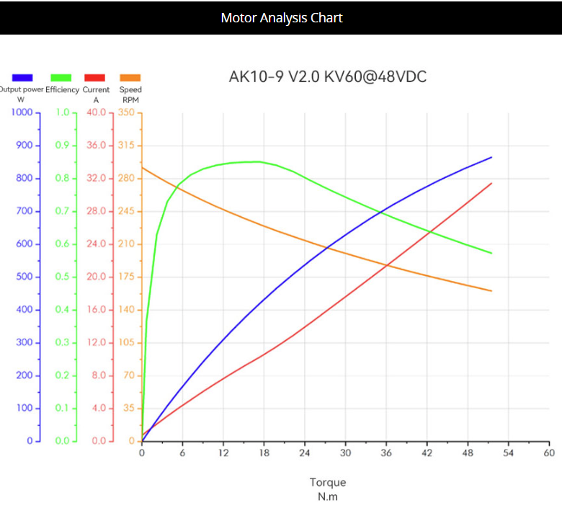  
(Source: Tmotor, n.d)

N.m to hp:

$$P(\text{HP})=\frac{T(\text{Nm})×N(\text{RPM})}{7127}$$

For 18nm:

$P(\text{HP})=\frac{18(\text{Nm})×228(\text{RPM})}{7127}$ = 0.576HP

For 25nm:

$P(\text{HP})=\frac{25(\text{Nm})×200(\text{RPM})}{7127}$ = 0.702 HP

### Determine the service factor.

Using Table 7-8 below, using good engineering judgement, a service factor of 1.2 has been selected.

Table  
Synchronous Belt Service Factor Table

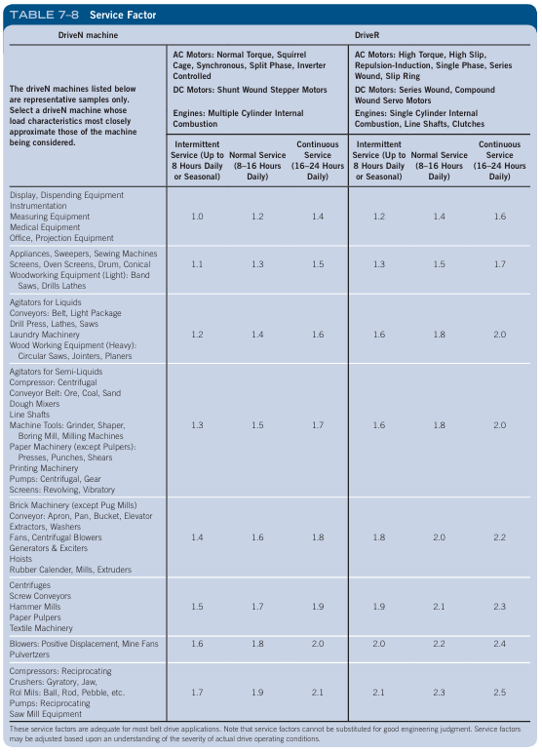  
(Source: Mott, Robert L, 2018)

### Calculate the design power.



Using the formula above;

- the design rated power is = 0.576HP x 1.2 = 0.691 HP (0.691 x 0.7457 = 0.52 kW)  
- the design peak power is = 0.702 HP x 1.2 = 0.8424 HP (0.8424 x 0.7457 = 0.63kW)

### Determine required pitch of the belt.

Graph  
GT Belt Selection Guide

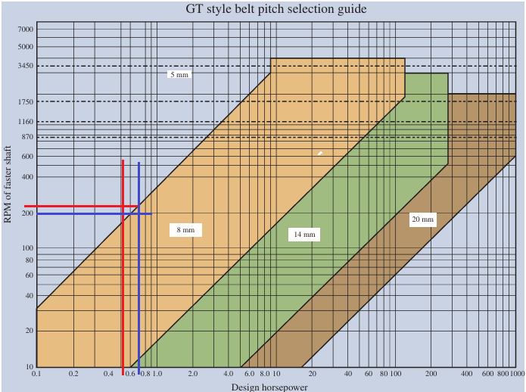(Source: Mott, Robert L, 2018)

Using the table above, the red lines depict the selection for the rated torque, whilst the blue lines indicate the use of peak torque. Since the majority of the imaginary curve from the red line intersection to the blue line intersection, a 5mm belt pitch would be considered a reasonable design choice. However, 8mm had to be chosen due to belt selection requirements.

### Determine the velocity ratio VR belt between the driver and driven sprockets.

To determine the sizes/ratio of the driven and driver pulleys, giving the following:

Motor operational torque: 18nm  
Required torque: 24.9nm

An adequate pulley size ratio is needed to meet the steering force requirement of 24.9nm.

As the torque ratio is directly related to the velocity ratio:

Torque ratio = $\frac{Torque Required (Driven)}{Motor Torque (Driver)}$

Using the values of 24.9nm of steering torque (with FOS 1.5), with 24.9nm of required torque,

**Torque ratio = $\frac{24.9 nm}{24.9nm}$ ≈ 1**

Therefore the driven pulley (on steering column shaft) must be **1** or more greater than the driver pulley (on the motor).

When the car is in motion, using a dynamic torque of 27nm (from 13.5N x FOS 2), At moderate dynamic or during sudden spikes:

Motor rated torque: 18nm  
Required torque: 27nm

**Torque ratio = $\frac{27 nm}{18nm}$ ≈ 1.5**

Thus, the driven pulley (attached to the steering column shaft) needs to be at least 1.38 times larger than the driver pulley (connected to the motor).

### Pulley selection

**5mm Pitch Belt:**

**8mm Pitch Belt:**

Table  
Screenshot of 8mm Synchronous Belt Drive Table Part 1

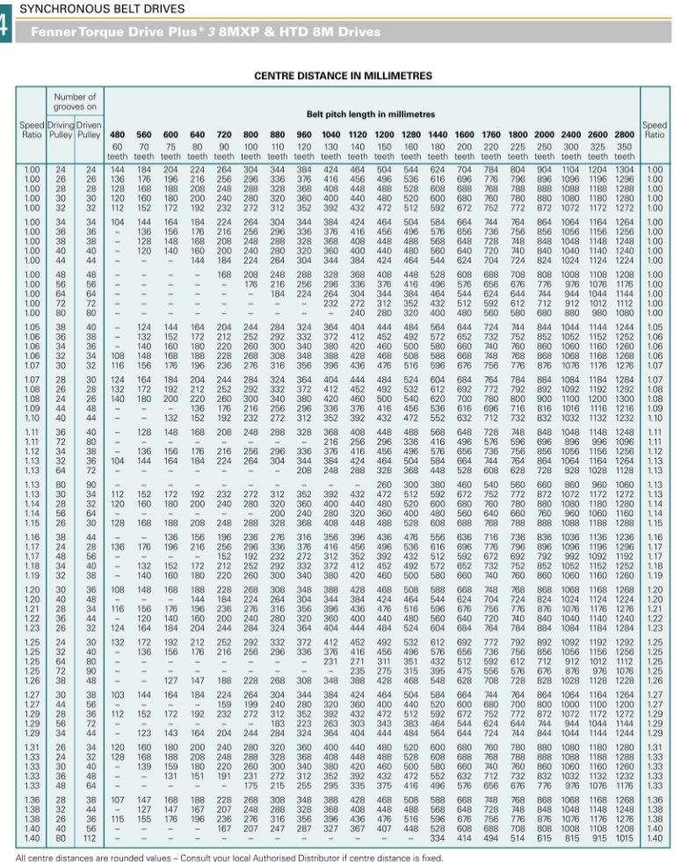(Source: Fenner, 2006)

Table  
Screenshot of 8mm Synchronous Belt Drive Table Part 2

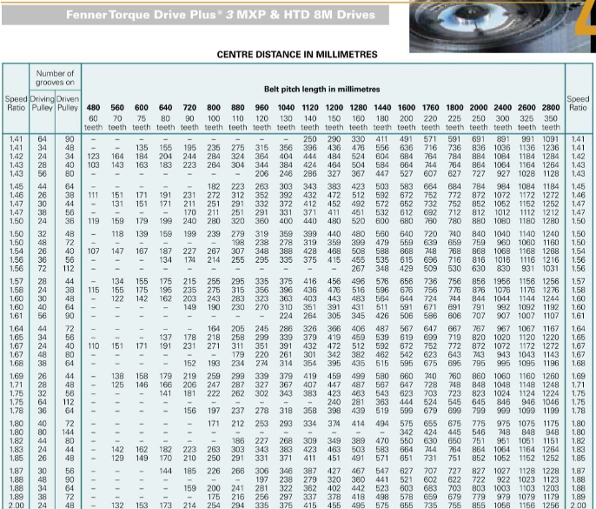(Source: Fenner. 2006)

## Analysis of Motor and Column Shaft

### Obtain dimensions from Solidworks ’22 Full Car Model

### Double U-joint Analysis

As there was no documentation on the design of the current steering shaft geometry model, an investigation was conducted.

Figure

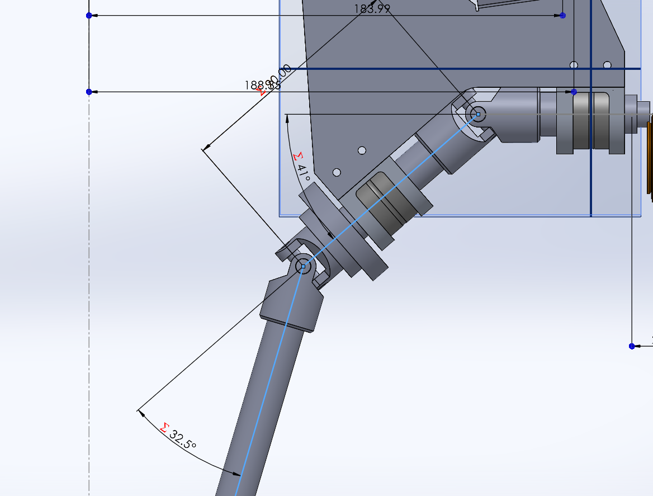

(Screenshot 1 of the lower joint angle and the entire double U-joint)

The current U-joint is double U-joint configuration, however through investigating the joint angles in Solidworks shown in the pictures above and below, the lower U-joint is angled at 32.5 degrees from the centre component axis, whilst the highest U-joint angle is approximately 37.5 degrees.`  
As both of the angles are not the same, a constant velocity relation is not present, meaning that the angular velocity on both outer shaft ends are not equal.  
This can cause torsional vibrations, which can accelerate wear and tear of the shafts’ bearings and joints. (RegalRexnord, nd.), and the overall efficiency of the steering joint mechanism (C.W Spicer, 1915).

Figure

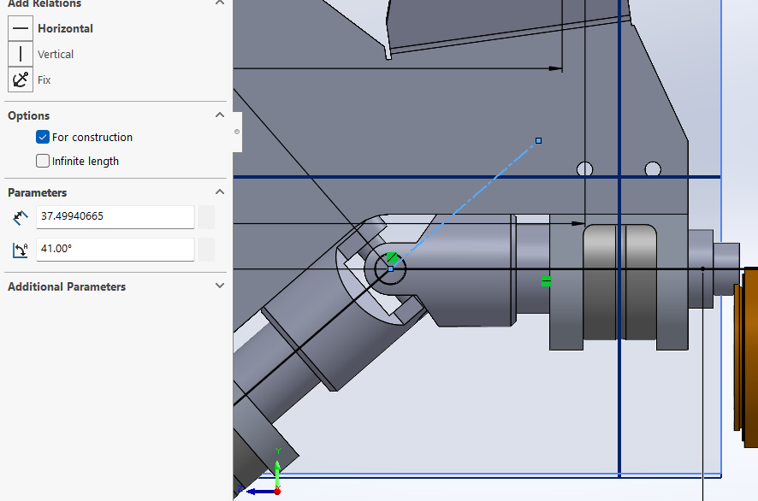  
(Screenshot 1 of the upper joint angle - closeup)

Due to time constraints and the lack of viability of Solution 1, Torsion was the only force calculated for the motor shaft and steering column for Solution 1. However, for Solution 2, both torsion and bending stress of the shafts has been hand-calculated and put through finite element analysis (FEA).

## Calculation – Motor Shaft Torsion – Solution 1

Polar moment of inertia of a solid bar, J:

$$J=\frac{π}{2}r^{4}$$

= $\frac{π}{32}D^{4}$

Using reasonable engineering judgement, 15mm diameter bar has been selected.

$$J=\frac{π}{32}\left(0.015^{4}\right)= 4.97×10^{-9} {\text{m}}^{4}$$

Shear Stress, τ:

Τ = $\frac{Tr​}{J}$

Using rated 9nm torque for AK80-9 Motor:

$τ=\frac{9 ⋅\left(\frac{0.015}{2}\right)}{ 4.97×10^{-9} {\text{m}}^{4} }≈13.58 ×10^{6} \text{Pa}$ = 13.58 MPa

Using peak 18nm torque Calculation (Solution 1), with AK80-9 Motor, or rated torque for AK10-9 (Solution 2) :

$τ=\frac{18 ⋅\left(\frac{0.015}{2}\right)}{ 4.97×10^{-9} {\text{m}}^{4} }≈ 27.16 ×10^{6} \text{Pa}$ = 27.16 MPa

Allowable shear stress estimate for steel can be given as:

τallow​ ≈ 0.5*ultimate yield stress

From a resource for general properties of steel, the yield strength of steel is 350 MPa.

τallow​ ≈ 0.5*350 = 175 MPa

Since the allowable shear stress is 175 MPa, which is 12.89 times higher than the theoretical shear stress of 13.58 MPa in the shaft, the shaft can safely support a torque of 9nm. With 18nm, since 175 MPa is 6.44 times greater than 27.16 MPa, the shaft can also safely support the peak torque of 18nm.

## Calculation – Hollow Steering Shaft Torsion – Solution 1

The shaft’s outer diameter is 15mm of the ’22 CAD model, however for the selected larger pulley for the steering shaft, part-named P72-8MGT-30, the minimum required shaft diameter/bore size for the 2517 taper locking bushing is be used as a pulley-to-shaft hub connection available to purchase in the Australian market (as of writing), is 16mm.   
Analysing the current 15mm outer diameter, 10mm inner diameter of the main section for of the steering shaft:

Since the main shaft is hollow, the polar moment J for a hollow circular shaft must be used:

Shear Stress, τ:

Τ = $\frac{Tr​}{J}$

where T is the applied torque, r is the distance from the centre to the stressed surface.

**Autonomous condition: Torque applied to shaft via motor – 9nm rated torque:**

Using gear ratio of 2.86, the rated torque at the motor is 9nm, the torque at the driven is:

9nm x 2.86 = 25.74Nm.

Shear Stress, τ:

$τ=\frac{25.74⋅\left(\frac{0.015}{2}\right)}{3.99×10^{-9}}≈$ 48.40 MPa

**Autonomous condition: Torque applied to shaft via motor – 18nm peak AK80-9 torque:**

Using gear ratio of 2.86, the rated torque at the motor is 18nm, the torque at the driven is:

18nm x 2.86 = 51.48Nm

Shear Stress, τ:

$τ=\frac{51.48⋅\left(\frac{0.01}{2}\right)}{3.99×10^{-9}}≈$ 96.77 MPa

**Manual drive condition: Torque applied to shaft via steering wheel:**

Using 25nm from FOS of 16.6nm steering torque. Due to vector quantity, the torques are not additive. When equal and opposite torques of 25 Nm are applied at both ends of the shaft, it results in a constant torque of 25 Nm on the shaft.

Shear Stress, τ:

$τ=\frac{25⋅\left(\frac{0.015}{2}\right)}{3.99×10^{-9}}≈$ 46.99 MPa

Allowable shear stress estimate for steel can be given as:

τallow​ ≈ 0.5*ultimate yield stress

From a resource for general properties of steel, the yield strength of steel is 350 MPa.

τallow​ ≈ 0.5*350 = 175 MPa

**Autonomous condition: Torque applied to shaft via motor – 9nm rated torque:**

Since the yield strength is 350 MPa, which is over 7 times higher than the theoretical shear stress of 48.40 MPa in the shaft, the shaft can safely support a torque of 9 Nm.

**Autonomous condition: Torque applied to shaft via motor – 18nm rated torque:**

Given that the yield strength is 350 MPa, which is more than 3.5 times the theoretical shear stress of 96.77 MPa in the shaft, it can safely withstand a torque of 18 Nm.

**Manual drive condition: Torque applied to shaft via steering wheel:**

Since the yield strength is 350 MPa, which is over seven times higher than the theoretical shear stress of 46.99 MPa in the shaft, the shaft can safely support a torque of 25 Nm with a reasonable factor of safety.

**Calculation – Steering Column Shaft Torsion:**

Polar moment of inertia of a solid bar, J:

$$J=\frac{π}{2}r^{4}$$

= $\frac{π}{32}D^{4}$

Using 15mm Shaft

$$J=\frac{π}{32}\left(0.015^{4}\right)= 4.97×10^{-9} {\text{m}}^{4}$$

Shear Stress τ:

Τ = $\frac{Tr​}{J}$

Using gear ratio of 2.86, the torque at the motor is 25nm (with FOS), the torque at the driven is:

25nm x 2.86 = 71.5Nm

Shear Stress:

$τ=\frac{71.5 ⋅\left(\frac{0.02}{2}\right)}{ 4.97×10^{-9} }≈143.86 ×10^{6} \text{Pa}$ = 143.86 MPa

Allowable shear stress estimate for steel can be given as:

τallow​ ≈ 0.5*ultimate yield stress

From a resource for general properties of steel, the yield strength of steel is 350 MPa.

τallow​ ≈ 0.5*350 = 175 MPa

Since the allowable shear stress is 175 MPa, which is 1.21 times higher than the theoretical shear stress of 143.86 MPa in the shaft, the shaft can safely support a torque of 25 Nm. This includes a factor of safety (FOS) of 1.5, based on a steering torque of 16.6 Nm.

## Calculation – Motor Shaft Torsion – Solution 2

Polar moment of inertia of a solid bar, J:

$$J=\frac{π}{2}r^{4}$$

= $\frac{π}{32}D^{4}$

20mm diameter bar has also been selected.

$$J=\frac{π}{32}\left(0.020^{4}\right)= 1.57×10^{-8} {\text{m}}^{4}$$

Shear Stress, τ:

Τ = $\frac{Tr​}{J}$

Using rated 18nm torque for AK10-9 Motor:

$τ=\frac{18⋅\left(\frac{0.020}{2}\right)}{ 1.57×10^{-8} {\text{m}}^{4} }≈11.46 ×10^{6} \text{Pa}$ = 11.46 MPa

The minimum diameter shaft of 9mm:

$τ=\frac{18⋅\left(\frac{0.009}{2}\right)}{ J }≈$ 125.75 MPa

The minimum diameter shaft of 12mm for taper lock bushing:

$τ=\frac{18⋅\left(\frac{0.012}{2}\right)}{ J }≈$ 53.05 MPa

Allowable shear stress estimate for steel can be given as:

τallow​ ≈ 0.5*ultimate yield stress

From a resource for general properties of steel, the yield strength of steel is 350 MPa.

τallow​ ≈ 0.5*350 = 175 MPa

Since the allowable shear stress is 175 MPa, which is 15.27 times higher than the theoretical shear stress of 11.46 MPa in the 20mm shaft, shaft can safely support a torque of 18nm.   
The minimum shaft to resist a torsion of 18nm is shaft size of 9mm, which is under the allowable shear stress of 175MPa. However, the smallest available taper lock bushing for the driver pulley is 12mm. As 53.05 MPa is smaller than the 350MPa yield strength of steel by a factor of 6.6, a 12mm shaft diameter is sound.

**Calculation – Steering Column Shaft Torsion:**

Using 15mm Shaft:

Polar moment of inertia of a solid bar, J:

$$J=\frac{π}{2}r^{4}$$

= $\frac{π}{32}D^{4}$

$$J=\frac{π}{32}\left(0.015^{4}\right)= 4.97×10^{-9} {\text{m}}^{4}$$

Shear Stress, τ:

Τ = $\frac{Tr​}{J}$

Using gear ratio of 1.5, the torque at the motor is 25nm (with FOS), the torque at the driven is:

25nm x 1.5 = 37.5Nm

Shear Stress:

$τ=\frac{37.5 ⋅\left(\frac{0.015}{2}\right)}{ 4.97×10^{-9}}≈$ 56.59 MPa

Using 20mm Shaft:

Polar moment of inertia of a solid bar, J:

$$J=\frac{π}{2}r^{4}$$

= $\frac{π}{32}D^{4}$

$$J=\frac{π}{32}\left(0.020^{4}\right)= 1.57×10^{-8} {\text{m}}^{4}$$

Shear Stress, τ:

Τ = $\frac{Tr​}{J}$

Using gear ratio of 1.5, the torque at the motor is 25nm (with FOS), the torque at the driven is:

25nm x 1.5 = 37.5Nm

Shear Stress:

$τ=\frac{37.5 ⋅\left(\frac{0.02}{2}\right)}{ 1.57×10^{-8} }≈23.89 ×10^{6} \text{Pa}$ = 23.89 MPa

Allowable shear stress estimate for steel can be given as:

τallow​ ≈ 0.5*ultimate yield stress

Using 22mm shaft:

$$J=\frac{π}{32}\left(0.022^{4}\right)= 2.31×10^{-8} {\text{m}}^{4}$$

Shear Stress:

$τ=\frac{37.5 ⋅\left(\frac{0.022}{2}\right)}{ J }≈23.89 ×10^{6} \text{Pa}$ = 17.86 MPa

From a resource for general properties of steel from MatWeb, the yield strength of steel is 350 MPa.

τallow​ ≈ 0.5*350 = 175 MPa  
  
For 15mm diameter shaft, Since the allowable shear stress is 175 MPa, which is much greater than the theoretical shear stress of 56.69MPa in the shaft, the shaft can safely support a torque of 25Nm, with a FOS of approximately 3.09.

For 20mm diameter shaft, since the allowable shear stress is 175 MPa, which is 7.3 times higher than the theoretical shear stress of 23.89 MPa in the shaft, the 20mm shaft can safely support a torque of 25 Nm. This includes a factor of safety (FOS) of 1.5, based on a steering torque of 16.6 Nm.

Likewise for the 22mm shaft, since it has a factor of safety of 15.59 from the value of 350 MPa divided by 17.86 MPa, the 22mm diameter is extremely over-engineered, on terms of undertaking torsion only force.

### Radial Force Calculation – Solution 2

## Combined Radial, bending and Torsion Calculation – Solution 2

**For Motor Shaft:**

Using Von Mises stress criterion for combing loading, we can calculate the combined effects of bending and shear stresses, where the alternating $σ_{a}$ or mean stress $σ_{m}$ can be calculated by:

Assuming bending moment applied to shaft is a mean value, of 12mm shaft, where $σb$ is the bending stress of 81.46 MPa, and τ is the torsional shear stress of 54.05MPa:

$σ$**= ${(81.46^{2}MPa+3 ×{53.05}^{2} ) }^{1/2}$**

**= 122.80 MPa**

As the allowable yield stress of 175MPa, the shaft 12mm diameter is within design limits. Comparing the to the yield strength of 350MPa, there is a factor of safety of 2.85 compared to the von Mises stress value of 122.80MPa.

**For Steering Column Shaft:**

**Free Body Diagram (FBD) of Lower Shaft Column:**

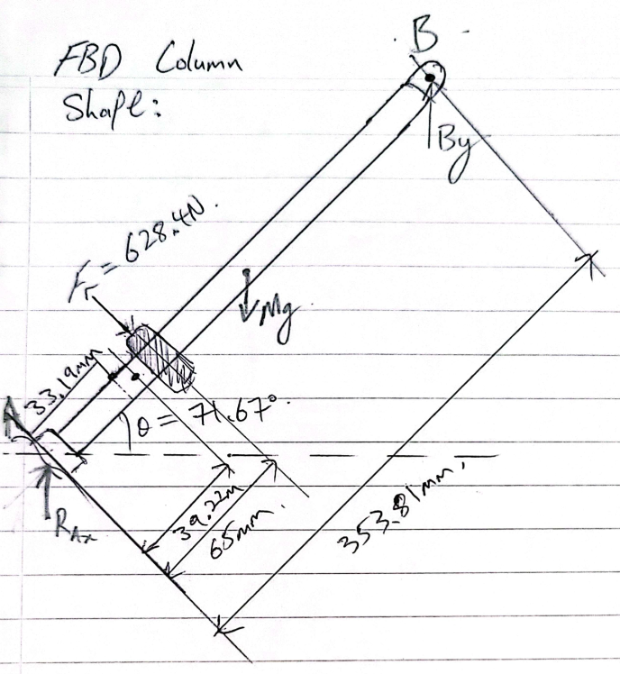

**Calculate Maximum Bending Moment:**

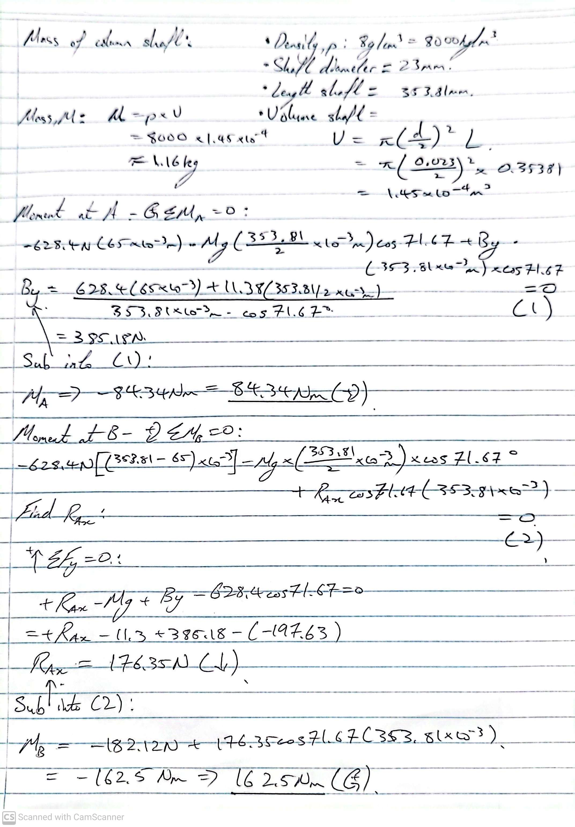

(Figure - Calculation 2 – Bending moment)

Referring the moment calculations above, neglecting the collective weight of the column shaft, pinion and U joint, the maximum moment occurs at around point B of 162.5Nm.

**Calculate Bending Stress:**

$$σ_{b= \frac{M × y}{I}}$$

Where y is the distance from neutral axis to the outer fibre, and I is the moment of inertia of a solid shaft, $πd^{4}$/ 64. Let the motor shaft diameter d be 20mm.

$$σ_{b= \frac{162.5 Nm ×(20 ×{10}^{-3}/2 )}{I}=206.90 MPa}$$

Since the $206.90MPa$ does not satisfy the allowable stress of 175MPa, a 20mm shaft diameter is not sufficient in diameter. Therefore, the current diameter of 15mm column shaft is not adequate.  
  
Let the column shaft diameter be 25mm:

$$σ_{b= \frac{162.5 Nm ×(25 ×{10}^{-3}/2 )}{I}= 105.93 MPa}$$

As $105.93$ MPa is below the yield strength of 350 MPa for steel by a factor of 3.3, 25mm size shaft will be able to safely resist the bending moment.

The minimum suitable shaft diameter using general steel is 22mm:

$$σ_{b= \frac{162.5 Nm ×(22 ×{10}^{-3}/2 )}{I}=155.45 MPa}$$

As $155.45 MPa$ is under the allowable shear stress of 175MPa, a diameter of 22mm is suitable for use.

Through selecting to improve the material’s properties, particularly yield strength through several methods such as heat treatment, or replacing the general steel with a steel that contains higher yield strength, a smaller diameter shaft can be used.

Using AISI 4140 heated treated to 870 degrees Celsius, it has a yield strength of 655MPa. (MtWeb, n.d) With a factor of safety of 6.18 and 4.21 compared to the shaft’s bending stress of the 25mm and 23mm shafts respectively, both scenarios surpasses the allowable yield strength of this particular 4140 steel at 327.5 MPa.

The minimum shaft diameter to satisfy the allowable yield strength (or FOS of 2), using 4140 steel for bending only is the size of 17mm:

$$σ_{b= \frac{162.5 Nm ×((17 ×{10}^{-3} )/2)}{I}=336.90 MPa}$$

Thus, a value of $336.90$ MPa has a FOS of 2.06 from the heat treated 4140 yield strength of 655MPa.

Neglecting Axial loads, using the Von Mises Stresses formula(s) for 22mm shaft (general steel):

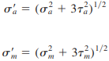

$σ$ = ${({155.45}^{2} MPa+3 ×{17.86 }^{2}) }^{1/2}$

= 158.5 MPa

The shaft of 22mm diameter does not satisfy the allowable yield stress of 175MPa, with a FOS of 2.2, compared the von mises stress value of 158.5 MPa to the yield strength of 350MPa.

Recalculating torsion for the shaft 17mm diameter for the selected 4140 steel:

Shear Stress:

$τ=\frac{37.5 ⋅\left(\frac{0.017}{2}\right)}{ J }≈$ 38.87 MPa

Recalculating Von Mises Stresses:

$σ$**= ${({336.90}^{2} MPa+3 ×{38.87}^{2}) }^{1/2}$**

= 343.56.02 MPa

As the allowable shear stress of 4140 Steel is 343.56.02 MPa, the 17mm shaft diameter does not satisfies the 2 times factor of safety of the allowable shear stress. However, the use of the 17mm shaft may be considered.

Verify if 18mm 4140 is feasible:

Shear Stress:

$$τ=\frac{37.5 ⋅\left(\frac{0.018}{2}\right)}{ J }≈32.75 MPa$$

Bending moment:

$$σ_{b= \frac{162.5 Nm ×((18 ×{10}^{-3} )/2)}{I}=283.81 MPa}$$

Von Mises Stresses:

$σ$**= ${({283.81}^{2} MPa+3 ×{32.75}^{2}) }^{1/2}$**

= 289.42 MPa

As the value of 289.42MPa is under 327.5MPa of the allowable shear stress, a shaft of 18mm of 4140 steel suitable.

### Axial Forces

Axial loads are usually comparatively small at critical locations where bending and torsions forces occur, therefore axial forces of both of the motor and column shafts have been omitted out of the equations., as the

## Finite Element Analysis Simulation

Using Solidworks, Finite Element Analysis (FEA) simulation was performed on the steering column shaft.

### Steering Column Shaft – Torsion forces modeled only

**15mm diameter general steel (1020):**

Modelling for torsion as the only modelled force, at the driver pulley’s location, which from the centre of the belt is approximately 65mm to the centre of the steering rack’s pinion on our physical prototype’s model, which is about 27mm from the bottom shaft’s edge. on the current 15mm diameter shaft (modified from hollow to solid)

(Figure - Screenshot of FEA Simulation – Shear Stress – Default mesh density)

(Screenshot of FEA Simulation – Shear Stress - Lower side of Column 15mm Shaft)

(Screenshot of FEA Simulation – FOS - Upper side of Column 15mm Shaft)

(Screenshot of FEA Simulation – FOS - Lower side of Column 15mm Shaft)

**23mm diameter general steel (1020):**

To more accurately simulate the torsion only along the main diameter of the shaft instead of with the smaller shaft extrusions on both ends, simulations on terms of shear stress along the length of the shaft was conducted with a plain 23mm shaft, of various mesh densities, on the coarsest setting, one other on the default setting, whilst the other one was conducted on the finest setting.  
From the Figures below, it can be seen that the finest mesh simulation, depicted the closest results out of the three simulations, which is almost identical results of a maximum shear stress of 15.83 MPa compared to the hand-calculated value of 15.70MPa.  
Surprisingly, the simulation with the coarsest density achieved more accurate results than the default computation (roughly set to half way between the coarse/fine slider.)

(Figure - Screenshot of FEA Simulation – Shear Stress – Default mesh density)

(Figure - Screenshot of FEA Simulation – Shear Stress – Coarsest mesh density)

(Figure - Screenshot of FEA Simulation – Shear Stress – Finest mesh density)

Shear stress simulation of the actual 23mm shaft model presented major variation of the stress distribution along the shaft. The Figure shown below portrayed a manual driving condition where the steering force from the wheels are exerted into the shaft, transferring to the shaft’s main face and along the surface area of the extruded side shaft.

(Figure - Screenshot of FEA Simulation – Shear Stress – Coarsest mesh density)

### Steering Column Shaft – All Calculated forces modeled

**23mm diameter general steel (1020):**

(Screenshot of FEA Simulation – Shear Stress - Upper side of Column 15mm Shaft)